SYE 6621 60039094 TIAN Linfeng
Introduction
1.1 Research Background
In recent years, Large Language Models (LLMs) have demonstrated strong natural language understanding and generation capabilities in the field of medical question answering. This paper considers designing an agent architecture to achieve specialized adaptation for the medical field, characterized by a layered design of the Memory library, diversified risk interception, and RAG confidence differentiation.
Based on the design goals of daily needs and health management, the main optimization targets are: 1) Designing a follow-up question structure to proactively ask questions to obtain further information when there is a need for information; 2) Combining historical medical records for comprehensive analysis and long-term memory ANN recall; 3) User input is chronological, and the temporal evolution of health factors needs to be considered; 4) Questions may involve potential medical risks, and it is necessary to distinguish between users' casual conversations and questions based on their own health conditions.
Using an LLM alone presents users with an extremely cumbersome process of repeatedly injecting their own health status prompts, and the model cannot inform users of any further confirmation needs. Furthermore, a single memory library cannot differentiate between different types of requests, leading to high recall difficulty, low accuracy, and prompt pollution. This design addresses these pain points with optimized solutions.
1.2 Pain Point Analysis
Using LLM alone in data-driven applications such as healthcare, which require synchronizing user status updates, presents several main problems:
（1）Lack of information supplementation ability
LLM can generate seemingly reasonable medical explanations even with incomplete information because its statistical model predicts the highest probability output. Lacking necessary information, it tends to err, rather than recognizing its own insufficient reasoning and proactively requesting supplementary information. This "strong answer bias" has limited impact in open-domain question answering, but in medical scenarios it can directly influence user decisions, thus becoming one of the core challenges in medical agent design.
Example: When a user simply enters "I have a headache, what could be the cause?", a single LLM (Local Management Model) will directly output possible causes such as migraines, tension headaches, and sinusitis, and provide relief suggestions. While this information may be statistically plausible, the system lacks crucial evidence such as the duration of the pain, the location of the pain, accompanying symptoms, and past medical history. Therefore, this type of response is a speculative generation based on probability distribution, rather than a risk assessment result based on sufficient medical evidence.
This project does not rely on LLM subjective evaluation output, but instead uses an explicit confidence calculation mechanism. It evaluates the output based on the match between the input text and the RAG recalled text, and proceeds to either the output or follow-up question branch based on the result. The Confidence Score consists of two parts:
Semantic Score：Vector similarity between the question and the recalled documents
Coverage Score：Keyword coverage
When the score falls below the threshold, the system considers the current knowledge insufficient to directly generate an accurate answer. Therefore, instead of generating an answer directly, it initiates a follow-up questioning process to gather more information and then re-search. The semantic similarity and keyword weights in this model are 0.6 and 0.4 respectively; further testing and fine-tuning are needed to determine the optimal weights.
(2) Recall pollution of a single memory library
Existing LLM memory solutions typically employ a unified storage and retrieval mechanism, storing user preferences, casual conversation content, and health-related information in the same memory space. However, health status in medical scenarios has significant time-sensitive and event-driven attributes, making it unsuitable for the same management approach used for ordinary conversational memories.
Example: Users may talk about diabetes, but in reality, their personal health does not include diabetes; unified storage will lead to significant recall prompt pollution.
To address this issue, this project divides the Memory database into three categories to store (1) user conversation memories, (2) user personal health data, and (3) the current system status. The system status is used for recall through cross-round, follow-up questions, and confidence routing. Physically isolating casual conversation from user health factors will significantly reduce the probability of prompt contamination.
2.1 Project Objectives
To address the aforementioned issues, this paper designs and implements a LangGraph-based Medical Agent, whose core objectives include:
(1) Information supplementation ability
Instead of generating speculative answers, the system proactively triggers follow-up questions when insufficient information is retrieved. Through multi-dimensional confidence calculations, it determines whether the current RAG possesses complete information to answer the question. The options are either directly outputting an LLM answer or entering a follow-up question branch to request the user to provide more health information for an accurate answer.
Implementation: A confidence assessment mechanism based on semantic similarity and keyword coverage.
(2) Memory pollution isolation
User conversation history and personal health data are stored in separate databases to avoid interference from conversation content in medical reasoning. A unified memory database is divided into a user conversation database, a user EHR information database, and a persistent current state database. The system divides persistent data into three layers: dialogue history, user EHR data, and cross-round system state. These three layers are physically isolated to avoid recall contamination.
Implementation method: Two-layer memory architecture, including user dialogue SQL and health data FAISS; at the same time, it maintains the current status information FSM for locating error nodes and error information.
Building upon this foundation, the system integrates auxiliary modules such as high-risk question and answer interception, question status classification, and answer strategy routing, forming a complete medical consultation workflow. The specific nodes of the system are shown in the figure.
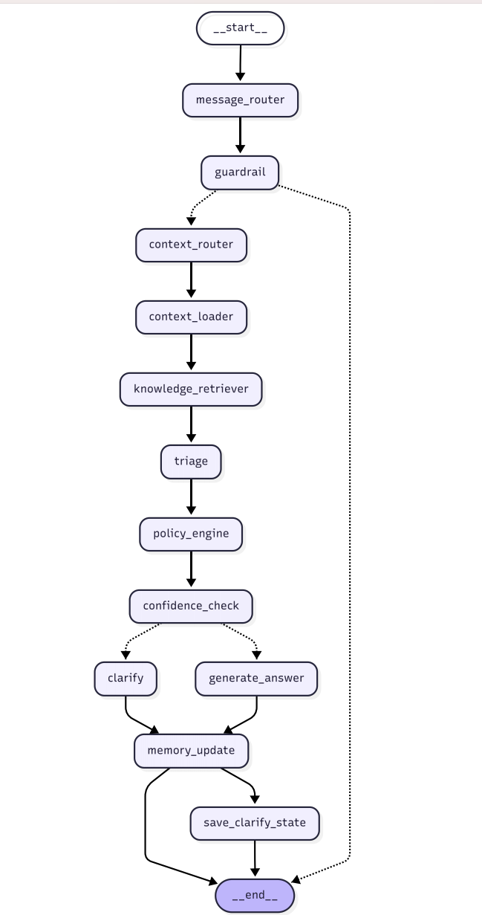

Listed by AI LLM：
Message router Determine if there were any follow-up questions from the previous round; if so, categorize them as new questions/answers/continue the topic.
guardrail LLM security audit; high-risk cases will be immediately terminated.
context router LLM determines whether an EHR (Expert Health Record) or a medical knowledge base is needed for the problem.
context loader Load user health data + conversation history (SQL + FAISS)
knowledge retriever Perform RAG knowledge retrieval on demand
triage LLM determines the urgency of a problem (emergency/urgent/routine).
policy engine Based on triage, it is mapped to response strategies (advisory/referral/emergency).
confidence check Confidence score below the threshold; if the score is below the threshold, proceed to clarification; otherwise, proceed to answer.
clarify Generate follow-up questions
generate answer Assemble the context and call LLM to generate the final answer.
memory update Write this round of questions and answers into memory.
save clarify state Persist the follow-up status to the database.

2.2 Mainstream LLM processing methods
ChatGPT and Mem0: Their strength lies in their knowledge base, but their recall quality has an upper limit in risky environments. Conversational and health data are stored together in a single database; however, due to the summary and storage mechanism, casual conversation can contaminate medical inference. Traditional medical question-answering systems (RAG + LLM): They can retrieve knowledge bases but lack risk assessment, follow-up questioning mechanisms, and confidence control. The above solutions, being designed for general applications, have areas for optimization when applied to specific risk scenarios.

In comparison, the risk-specialized system designed in this solution includes risk assessment, high-risk checks, RAG confidence + follow-up questioning mechanisms, and separate storage of chat memories and health data, effectively addressing these pain points.
3.1 Conclusion
This paper proposes a Medical Agent for routine medical consultations and long-term health management scenarios. It addresses information contamination through memory isolation, mitigates speculative responses through confidence-based routing, and ensures output security through risk grading. This method adds structured controls required for medical scenarios to the capabilities of general LLM (Medical Agent Model), improving the accuracy and security of cross-round consultations.

